Gefäss schätzen, abmessen und den Unterschied berechnen AB 1
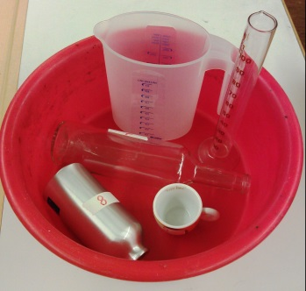
zu ZB 48/2 Schätze in ml, cl oder dl

Gefäss | geschätzt | gemessen | Unterschied
1 | _____________________ | _____________________ | _____________________
2 | _____________________ | _____________________ | _____________________
3 | _____________________ | _____________________ | _____________________
4 | _____________________ | _____________________ | _____________________
5 | _____________________ | _____________________ | _____________________
6 | _____________________ | _____________________ | _____________________
7 | _____________________ | _____________________ | _____________________
8 | _____________________ | _____________________ | _____________________
9 | _____________________ | _____________________ | _____________________
10 | _____________________ | _____________________ | _____________________
11 | _____________________ | _____________________ | _____________________
12 | _____________________ | _____________________ | _____________________

